**[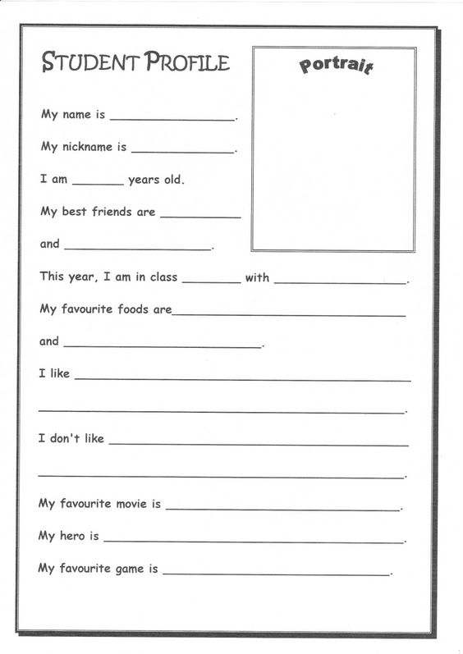](http://iepdigitalresourceroom.blogspot.com/p/other-resources.html)**